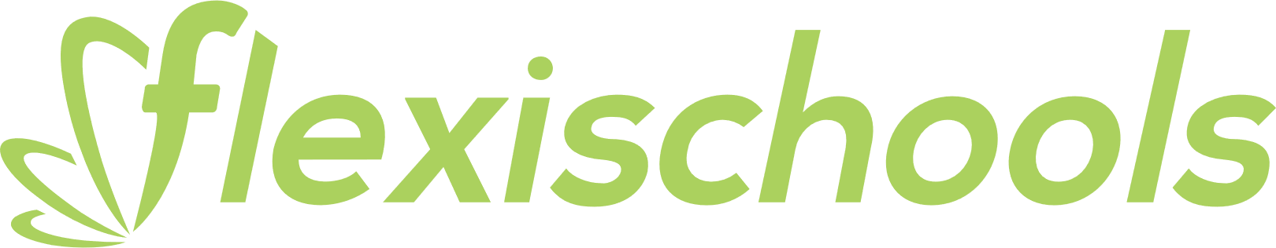

Fruits and snacks

Carrot sticks

Carrot sticks and dip

Piece of fruit (seasonal)

Cheese and cracker

Popcorn (small)

Popcorn (large)

Custard

Jelly

Boiled egg

Yoghurt

Watermelon bowl (small)

Watermelon bowl (large)

Grape bowl

Fruit salad (small)

Fruit salad (large)

Fruit salad and yoghurt

Fruit salad and custard

Pancakes

Red rock chips or Grainwaves

Ham and Cheese Roll

**Northlakes Public School**

$1.50

$2.00

$1.00

$2.00

$0.50

$1.00

$1.00

$1.00

$1.00

$1.50

$2.00

$3.50

$2.00

$2.50

$4.50

$5.50

$5.50

$2.00

$1.50

$2.00

$3.00

$4.00

$4.00

$4.50

$4.50

$5.00

$6.00

Toasties

Cheese

Ham and cheese

Cheese and tomato

Ham, cheese and tomato

Ham, cheese and pineapple

Chicken and cheese

Chicken, cheese and avocado

$1.00

$2.00

$2.00

$1.50

$2.00

$1.00

$2.50

$2.00

$2.000

Breakfast

Mini scrolls (pack of 3)

Mini scrolls (pack of 6)

Ham and cheese roll

Yoghurt

Hot chocolate

Fresh fruits

Fruit salad

Pancakes

$0.50

$0.50

$0.50

Vegetarian

Fried rice

Macaroni cheese bake

Vegetarian pizza

Vegie burger

Sauces

Tomato sauce

BBQ sauce

Mayo

$1.00

$2.00

$2.00

$2.50

$2.50

$2.50

$2.50

$2.50

$5.00

$5.00

$4.50

$5.50

Drinks

Water (small)

Water (large)

popper

Up and go

Oak milk

Milkshake

Juice bomb

Slushie

$7.00

$5.50

$4.50

$3.00

$5.00

$0.50

$1.00

$2.20

Gluten free

Chicken tender wrap

Pasta Bolognese

Cheese pizza

Nuggets (3)

Nuggets (6)

Popcorn (small)

Popcorn (large)

Pancakes

Daily Deals

Mini chicken wrap and drink

Spaghetti Bolognese and drink

Macaroni bake and drink

Pizza and garlic bread

Burger and drink

$5.00

$6.50

$6.50

$5.50

$7.50

$2.00

$3.50

$4.00

$4.00

$2.50

$4.00

$1.00

$6.00

$5.00

$5.00

$5.00

$5.00

$3.50

$4.00

$4.50

$4.50

$4.50

Hot items

Garlic bread

Sausage roll

Beef pie (lean)

Spinach and ricotta roll

Nuggets (3)

Nuggets (6)

Corn cob

Chicken and vegetable soup

Spaghetti Bolognese

Macaroni cheese bake

Butter chicken with rice

Fried rice with chicken

Cheese pizza

Ham pizza

Ham and pineapple pizza

Vegetarian pizza

BBQ chicken

Turkish melts

chicken, cheese and   
avocado $7.00

ham, cheese and   
pineapple $7.00

Sandwiches

Choose from wholemeal or   
white bread   
Change to gluten free bread   
Change to roll

Cheese/Vegemite/Honey

Cheese and Tomato

Tuna/Ham

Egg, Lettuce and Mayo

Ham Cheese and Tomato

Chicken

Salad

Ham and Salad

Chicken and Salad

$5.00

$6.00

$6.00

$6.00

$6.00

$3.50

$5.50

$6.00

$6.00

Burgers and wraps

Cheeseburger   
meat, cheese and tom sauce

Beef Burger   
meat, cheese, tom, lettuce, beetroot,

BBQ sauce

Chicken Burger   
chicken, lettuce, mayo

BBQ Chicken Burger  
chicken, cheese and BBQ sauce

Vegie Burger   
chickpea and lentil patty, lettuce, tom, sweet chilli

Mini chicken tender wrap

Tender, lettuce, cheese and mayo

Chicken Tender Wrap  
chicken tenders, lettuce, tomato, cheese and mayo

Ham & salad wrap

Ham, lettuce, cheese, tomato, beetroot, cucumber and carrot

Chicken & salad wrap

Chicken, lettuce, cheese, tomato, beetroot, cucumber, carrot

$5.50

$6.50

$0.50

$1.00

$0.20

$0.50

$1.00

$1.00

$1.00

$1.50

$1.00

$2.00

Frozen treats

Frozen milk cups

Quelch ice blocks

Juicie ice blocks

TNT ice mony

TNT

Moosie

Frozen juice cup

Frozen yoghurt

**Northlakes Public School**

Salads

Garden salad   
lettuce, cheese, tomato, beetroot,   
cucumber, carrot and dressing

Caesar salad   
Lettuce, parmesan, cheese, egg,  
 croutons, ham and dressing

Add extras

Lettuce, tomato, carrot,   
beetroot, cucumber or onion.

Cheese, pineapple, egg,   
avocado, ham, chicken or tuna

$1.50  
$0.50

$2.50

$3.00

$3.50

$4.00

$4.00

$4.00

$5.00

$6.00

$6.00