Welcome to Kindergarten
at Northlakes Public School
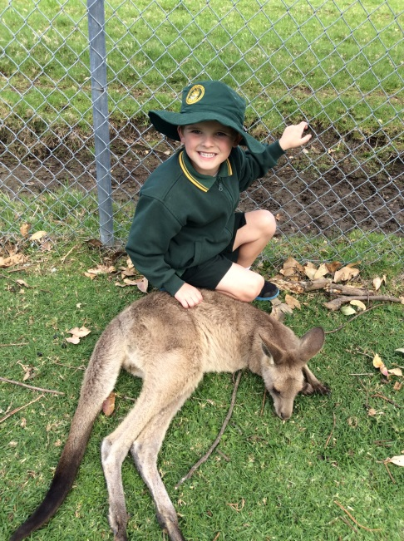
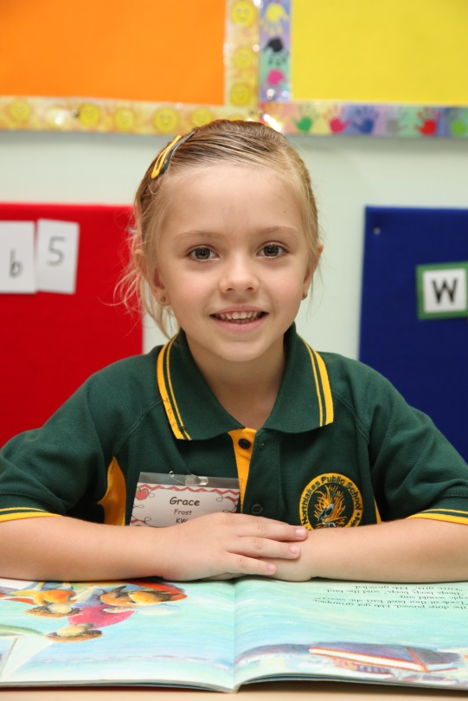
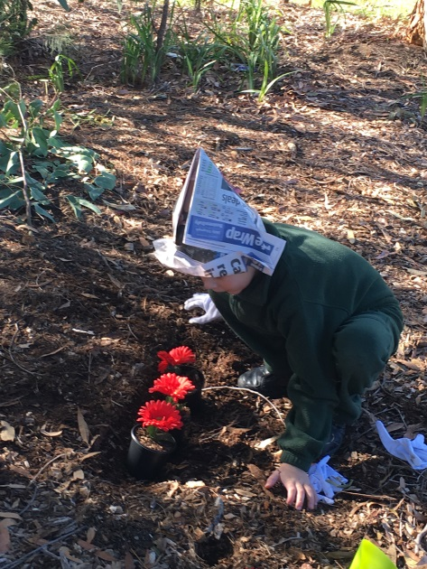

Parent Handbook

Successful Students at Northlakes are:
Respectful Safe Learners
Everyone Everywhere Everytime

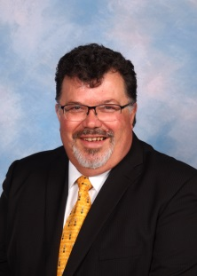
A message from the Principal

At Northlakes Public School we are committed to providing quality education for children from a wide range of backgrounds. Established in 1991, the school offers a comprehensive education that caters to the needs of all students.

Students are able to participate in a wide range of classroom and extra curricula activities. There are music lessons, student leadership programs, environmental education projects, excursions and a diverse in-school and interschool sporting program.

Student wellbeing is a high priority of the school. We share the responsibility of providing a safe and happy school environment. Teachers strive to meet the individual needs (academic, social, emotional, physical and spiritual) of our students. Parents play a vital role in ensuring that their children come prepared for school, organised with equipment and homework, and encouraged to behave well and work hard. Healthy eating, adequate sleep and exercise are essential to our children’s growth and development.

Community consultation and participation are strong features of the school, with an active Parent and Citizens association and opportunities for parents and the community to share and celebrate all the great things we do at the school.

As parents, you are always welcome to visit the school and participate in all of the school’s activities. As parents or teachers we succeed best when there is co-operation and purposeful communication. Appointments to speak with staff can be made by phoning the school or calling at the office. This enables a mutually convenient time to be arranged.

This information booklet is designed to answer many of the questions you might have about our day-to-day activities and routines. Keep the booklet handy as a reference. You will find that changing circumstances will require alterations to be made to this document from time to time. If you can make these alterations when they are announced through the school newsletter, you will be sure that the booklet is always up to date and so will remain useful.

Mr L Micevski - Principal

NORTHLAKES PUBLIC SCHOOL
PRINCIPAL: Larry Micevski
POSTAL ADDRESS: Goorama Ave San Remo 2262
TELEPHONE: 4399 2071
FACSIMILE: 4399 1935
WEBSITE: http://www.nothlake-p.schools.nsw.edu.au/
EMAIL: northlake-p.school@det.nsw.edu.au
GENERAL ORGANISATIONAL PROCEDURES
School Times
7.45am Breakfast Club – Monday, Tuesday, Wednesday and Thursday
8.10am Supervision of children under COLA and basketball court
8.30am Music - children have a few minutes to use toilet and get a drink
8.30am SESSION ONE
10.30am First Break
11.15am SESSION TWO
1.00pm Second Break
1.30pm SESSION THREE
2.30pm Classes dismissed – End of the school day

School Term Dates 2020

Students begin Last day for students
Term 1 Wednesday 29 January 2020 - Thursday 9 April 2020
Term 2 Tuesday 28 April 2020 - Friday 3 July 2020
Term 3 Tuesday 21 July 2020 - Friday 25 September 2020
Term 4 Monday 12 October 2020 - Wednesday 16 December 2020

School Development Days:
First Day of Term 1, First Day of Term 2, First Day of Term 3 and Last Two days of Term 4
(These dates are subject to change from school to school)

The Core Rules

All students in NSW government schools are expected to:

- Attend every school day, unless they are legally excused, and be in class on time and prepared to learn.
- Maintain a neat appearance, including adhering to the requirements of the school’s uniform or dress code policy.
- Behave safely, considerately and responsibly, including when travelling to and from school.
- Show respect at all times for teachers, other school staff and helpers, by following class rules, speaking courteously and cooperating with instructions and learning activities.
- Treat one another with dignity and respect.
- Care for property belonging to themselves, the school and others.

Behaviour that infringes on the safety of others, such as harassment, bullying and illegal or anti-social behaviour of any kind, will not be tolerated.

GENERAL SCHOOL BUSINESS
Sick Children and Absences From School
Once children are enrolled at school, parents are legally required to send them every day the school is open. Parents may be prosecuted if children of compulsory school age have a recurring number of unjustified absences.
If your child is unable to attend school, you must explain the reason for their absence. You are able to send a note to the class teacher when they return to school or you may contact the school through the office.
Where possible, please keep sick children at home. Not only does it help prevent the spread of germs throughout the class but children are more comfortable at home resting, instead of enduring a busy school day. Always send an explanation note to the teacher on the day your child returns or contact the school office.
Late Arrival
Our school day starts at 8.30am and it is a Department of Education requirement that all students are here by then. As per our Attendance Policy, if arriving after the bell, you must accompany your child to the office to sign them in and provide a reasonable explanation as to why they are late. If your child is constantly late you may be required to attend a meeting with the Home School Liaison Officer.
Early Release Notes
If you need to pick up your child early from school, you need to obtain an early release note from the office before collecting your child from their classroom.
Dropping Off and Picking Up
When dropping off and picking up children, please do not drive into the school grounds. The car park is for STAFF USE ONLY. We wish to avoid any serious accidents. Many support vehicles use this access and we need to ensure that they have priority.
Please walk children to and from school to avoid them crossing busy roads unsupervised. You can drop your children in our Kiss and Drop Zone.

Lunch Orders
If you need to order recess / lunch for your child, please place the money in a bag or envelope. Write child’s name, class & food required.
e.g. Julie Smith Class: KD
1 egg sandwich
1 orange juice
$ 5.00 enclosed
The bag or envelope will be collected in the classroom. Orders must be placed no later than 8:30am.
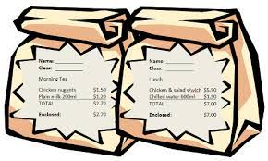
Orders can also be placed on-line using Flexischools:
To Register for Flexischools:
Go to flexischools.com.au and select the Register button and enter your email. You will be sent a registration email with a link to the registration page. Follow the instructions in the email to set up your account.
Once your account is set up add your students and select their school and class.
OR
Download the Flexischools app from the App Store or Google Play
Ordering on Flexischools:
Go to the flexischools.com.au and select the My Account button and login.
To place an order, click on the ‘online ordering’ button for you student.
Select the items you wish to order.
Once completed select your payment option. Complete payment to place your order.
Once registered, you can start placing orders immediately. If you have any questions please contact the Flexischools Customer Service Team on 1300 361 769, or you can contact them via their website.

P&C
Our P&C meet once a term in Jabiru Cottage at 2:45pm and new members are always welcome.
Uniform Shop Hours
Monday 2:15 – 2:45pm Wednesday 2:15 – 2:45pm Friday 8:15 – 9:15am
Orders can be paid for in cash at the Uniform Shop or online using Flexischools.
Money Collection -Parent Online Payments (POP)
Money can be put into the payment box located in the school foyer or you may use the Parent Online Payment (POP) found on the school’s website. Payments can be made using either a Visa or MasterCard credit or debit card. This is a secure payment system hosted by Westpac to ensure that your credit/debit card details are captured in a secure manner, these details are not passed back to the school.
When you access POP you must enter:
1. the student's name
2. date of birth+
3. the Ref. or Invoice (if applicable)
4. the Payment Option (from permission note)
5. the Payment Description (from permission note)
6. the amount you are paying
These details need to be entered each time you make a payment as student information is not held within the payment system. No student details are given to Westpac. As a consequence, payments for each child need to be made separately.
You can print your own receipts giving you immediate proof that you have paid for the item. Record your receipt number on the permission note and return it to school as normal. Your payment will be reconciled against the receipt number on the permission note.
Making an online payment does not constitute permission.

Buses - School Opal Card
The new Student Opal Card will be provided to eligible students at the beginning of 2020.
How to apply for the pass:
Step 1 Complete the application at transportnsw.info/school-students. This will be sent to school for approval.
Step 2 The School Opal card will be sent to the address provided on the application.

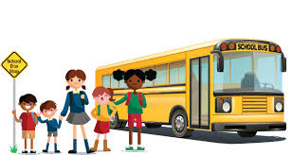

Health Care Plans and Medication
If your child suffers from a medical condition, allergy or requires medication please call the office to organise an appointment. You will be required to supply the school with a health care plan signed by your doctor. If prescribed dosage is less than a full tablet e.g. ½ tablet or ¼ tablet, medications must be provided to school in a Webster pack or similar prepared to correct dosage by the Pharmacist. Full tablets must be in original packaging.
The school can only administer medications as listed on the Health Care Plan. This means that if your child misses a dose at home we can no longer give them the missed dose. The Parent/Carer is required to administer the medication to the student at school.
Students attending excursions will need to bring their medication labeled with their name and dosage/times required from home, this includes asthma puffers, epi-pens and tablets, or they will not be able to attend excursions.
Medicines and tablets are not to be given to children to bring to school. Teachers are not allowed to give medication to children at school.
Newsletter
The School Newsletter comes home fortnightly on a Tuesday with the youngest child in each family. Please read it for lots of important information and special events.
Long Break, Short Break & Canteen
Our long break of the day takes place in the morning from 10.30 – 11.15. This is our time for lunch orders. Any hot food or sandwiches will be made available at this time. When ordering from the canteen, please write your child’s name, class and order on a paper bag. You can also order your child’s lunch at the canteen in the mornings before school or use our flexischools app. The canteen only cooks to order so there will only be a limited range of products available to purchase during playtime.
Our short break of the day is at 1.00 – 1.30. You can still have an order at this time, however children will need to pick it up from the canteen.
Headlice
Unfortunately, this is a part of school life. If a note is sent home from your child’s teacher mentioning a case of headlice, please check your child’s hair and treat if necessary. Notes are sent to the whole class each time.
K-2 Assembly
K-2 Assembly is held every fortnight on Thursday at 12.10. Parents are requested to wait for the gate to be opened before proceeding to the Hall. Host classes and times are published in the school Newsletter.
Library
Each week your child will attend Library lessons with Mrs Burt. They will need to have a suitable library bag in order to borrow books for the week. Children will need to return their books each week in order to borrow news books.

